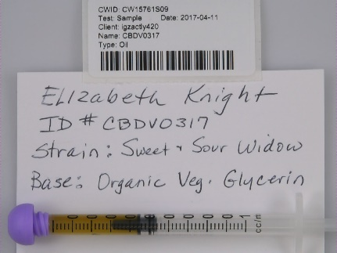 Sample CW15761S09
Sample Name: | CBDV0317
Tested On: | 2017-04-11
Expiration Date: | 2017-10-08 | Moisture: | 0.0%
Sample Type: | Oil
Strain: | Sweet & Sour Widow
No. Tests: | 3

Profiling by Liquid Chromatography
Cannabinoid | Percent | mg/g
d9-THC | 0.10 | 1.03
d8-THC | 0.00 | 0.00
THCA | 0.00 | 0.00
THCV | 0.00 | 0.00
CBC | 0.00 | 0.00
CBG | 0.00 | 0.00
CBGA | 0.07 | 0.68
CBN | 0.00 | 0.00
CBD | 1.08 | 10.75
CBDV | 0.00 | 0.00
CBDA | 2.12 | 21.15
Total | 3.36 | 33.61
Percent Decarboxylated: ~100%
d9-THCd9-THCd8-THCd8-THCTHCATHCATHCVTHCVCBCCBCCBGCBGCBGACBGACBDCBDCBDACBDACBDA2.1%
3.36%
Total Cannabinoids

Microbiological Screening
 | Count | Client Limit** | Status
Aerobic Plate Count | <100,000 | 100,000 | Pass
Yeast & Mold | <10,000 | 10,000
Coliform | <100 | 100
E Coli | <10 | 10
Pseudomonas | <0 | 0
Salmonella | NA | 0
**Client Limit is self-selected and will be replaced by official CA State limits when they become available.

Terpene Profiling
0.00% Total Terpenes by Weight
 | Percent |  | Percent
b-Myrcene | ND* | Camphor | ND*
Nerol | ND* | Borneol | ND*
Nerolidol | ND* | Pulegone | ND*
Ocimene | ND* | Cedrol | ND*
a-Bisbolol | ND* | b-Caryophyllene | ND*
Farnasene | ND* | Elemene | ND*
Valencene | ND* | Phellandrene | ND*
d3-Carene | ND* | Isopulegol | ND*
d-Limonene | ND* | Linalool | ND*
g-Terpinene | ND* | (+)-Fenchone | ND*
a-Pinene | ND* | a-Caryophyllene | ND*
Sabinene | ND* | Guaiol | ND*
b-Pinene | ND* | Bergamotene | ND*
Camphene | ND* | Terpineol | ND*
Eucalyptol | ND* | Terpinolene | ND*
(-)-Fenchone | ND* | a-Terpinene | ND*
Fenchol | ND*
*ND = Non-Detect

